deJS Apps Exam – Meme Lounge Single Page Application

Using libraries like jQuery, Handlebars and Sammy is allowed but is not obligatory. You are assigned to implement a Web application (SPA) using HTML5, JavaScript, AJAX, REST and JSON with cloud-based backend (Kinvey). The app keeps users and listings. Users can register, login, logout , view a catalog with all memes sorted by time (a helper function will be given), create a meme, edit/delete their own memes,show meme details and a userProfile where they can view their own memes and delete their profiles.

Create a Kinvey REST Service

Register at Kinvey.com and create an application to keep your data in the cloud.
In the Users collection, import the provided JSON file with sample users to get started with template data. In the Kinvey Console, select Users from the navigation of the left, click Settings in the upper right then scroll down to the Import section:

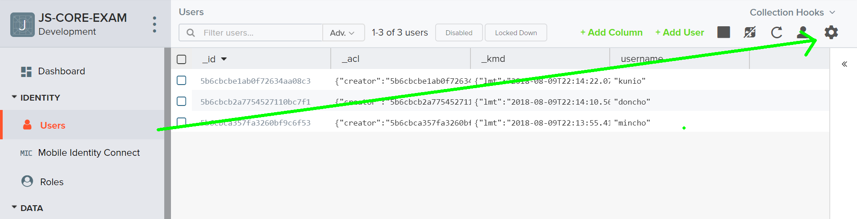

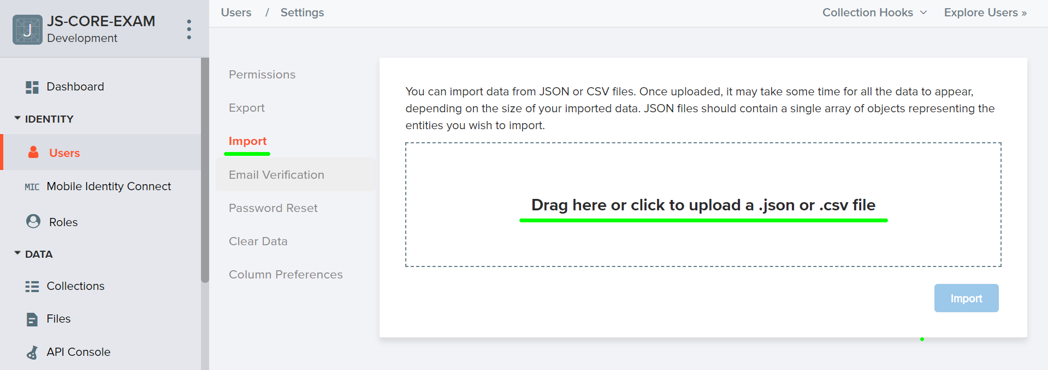

Create a collection memes. Each meme has a title ,description ,imageUrl and an creator (username of the creator).
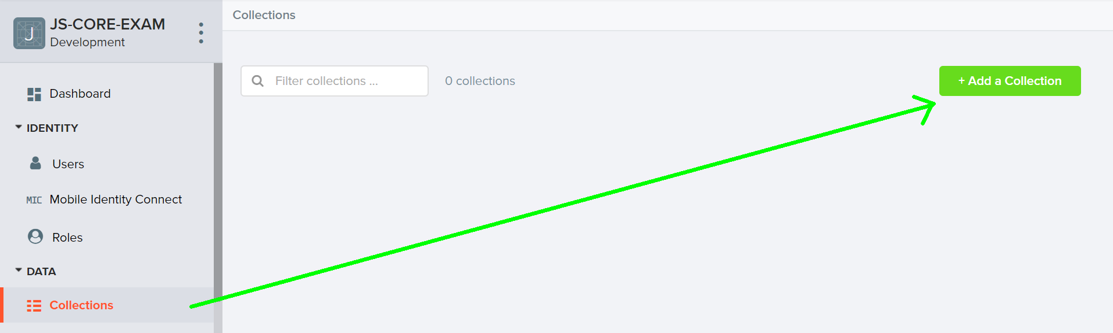
You are also given one more json files to import data for cars.

Test the Kinvey REST Services
Using Postman or other HTTP client tool (you can use Kinvey’s built-in API Console), test the REST service endpoints:

User Registration (Sign Up)
POST https://baas.kinvey.com/user/app_id/
Request headers | Authorization: Basic base64(app_id:app_secret)  Content-Type: application/json
Request body | {  "username": "testuser",  "password": "testuserpass890"  }
Response  201 Created | {  "_id": "59930c78a743e20c7d3fca77",  "username": "testuser",  "password": "testuserpass890"  }
Error response  409 Conflict | { "error": "UserAlreadyExists", "description": "This username is already taken. Please retry your request with a different username", "debug": "" }
Error response  401 Unauthorized | { "error": "InvalidCredentials", "description": "Invalid credentials. Please retry your request with correct credentials", "debug": "" }
The request needs “Basic” authentication. Use the Kinvey App Key and Kinvey App Secret as credentials.
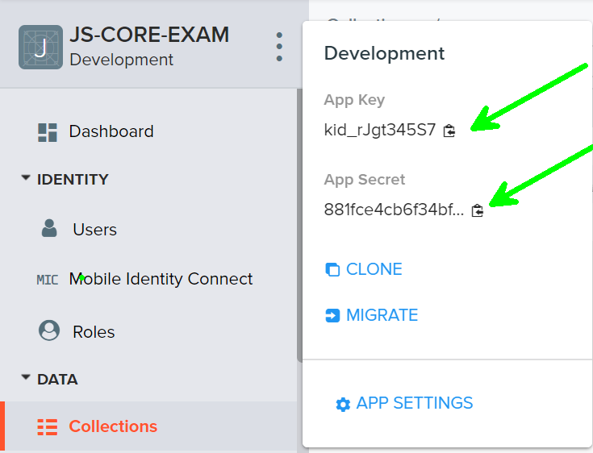

User Login
POST https://baas.kinvey.com/user/app_id/login
Request headers | Authorization: Basic base64(app_id:app_secret)  Content-Type: application/json
Request body | {  "username": "testuser",  "password": "testuserpass890"  }
Response  200 OK | {  "_id": "59930c78a743e20c7d3fca77",  "username": "testuser"  "_kmd": {  "authtoken": "8e6471bc-3712-4cfb-b92e-50e62a0c80….Duj5fHdM /7XHIe6KdY="  …  },  …  }
Error response  401 Unauthorized | { "error": "InvalidCredentials", "description": "Invalid credentials. Please retry your request with correct credentials", "debug": "" }
Successful login returns an “authtoken” which is later used to authenticate the CRUD operations.

User Logout
POST https://baas.kinvey.com/user/app_id/_logout
Request headers | Authorization: Kinvey authtoken
Response
204 No Content
Error response  401 Unauthorized | { "error": "InvalidCredentials", "description": "Invalid credentials. Please retry your request with correct credentials", "debug": "" }
To logout, you need to provide the “authtoken” given by login / register as “Kinvey” authorization header.

List all Memes (MemeFeed – sorted by meme time, descending)
GET https://baas.kinvey.com/appdata/app_id/memes?query={}&sort={"_kmd.ect": -1}
Request headers | Authorization: Kinvey authtoken
Response  200 OK | [  {  "title": "Very Funny Meme",  "description":"I cand hold it its hilarious",  "imageUrl":"url-link",  "_acl": {  "creator": "kid_B1zfi_e_Z"  },  "_kmd": {  "lmt": "2017-08-15T14:40:19.182Z",  "ect": "2017-08-15T14:40:19.182Z"  }  },...  ]
Error response  401 Unauthorized | { "error": "InvalidCredentials", "description": "Invalid credentials. Please retry your request with correct credentials", "debug": "" }

Create Meme
POST https://baas.kinvey.com/appdata/app_id/memes
Request headers | Authorization: Kinvey authtoken  Content-Type: application/json
Request body | {  "title": "Very Funny Meme",  "description":"I cand hold it its hilarious",  "imageUrl":"url-link",  }
Response  201 Created | {  "_id": "59931398996ab5127d2a84d1",  "title": "Very Funny Meme",  "description":"I cand hold it its hilarious",  "imageUrl":"url-link",  }
Error response  401 Unauthorized | { "error": "InvalidCredentials", "description": "Invalid credentials. Please retry your request with correct credentials", "debug": "" }

Edit Meme
PUT https://baas.kinvey.com/appdata/app_id/memes/meme_id
Request headers | Authorization: Kinvey authtoken  Content-Type: application/json
Request body | {  "title": "Very Funny Meme",  "description":"I cand hold it its hilarious",  "imageUrl":"url-link",  }
Response  200 Ok | {  "_id": "59931398996ab5127d2a84d1",  "title": "Very Funny Meme",  "description":"I cand hold it its hilarious",  "imageUrl":"url-link",  }
Error response  401 Unauthorized | { "error": "InvalidCredentials", "description": "Invalid credentials. Please retry your request with correct credentials", "debug": "" }

Delete Meme
DELETE https://baas.kinvey.com/appdata/app_id/memes/meme_id
Request headers | Authorization: Kinvey authtoken
Response  200 OK | {  "count": 1  }
Error response  404 Not Found | { "error": "EntityNotFound", "description": "This entity not found in the collection", "debug": "" }
Error response  401 Unauthorized | { "error": "InvalidCredentials", "description": "Invalid credentials. Please retry your request with correct credentials", "debug": "" }

Get User By Id
GET https://baas.kinvey.com/user/app_Id/userId/
Request headers | Authorization: Kinvey authtoken
Response  200 OK | [  {  "username": "testuser",  “email": “email”,  “imageUrl”:”url”  }  ]
 | { "error": "InvalidCredentials", "description": "Invalid credentials. Please retry your request with correct credentials", "debug": "" }

User Memes(View all Memes by username, sorted by post time, descending)
GET https://baas.kinvey.com/appdata/app_id/memes?query={"creator":"username"}&sort={"_kmd.ect": -1}
Request headers | Authorization: Kinvey authtoken
Response  200 OK | [  {  "_id": "599307d36af42b495f87bad2",  "title": "Very Funny Meme",  "description":"I cand hold it its hilarious",  "imageUrl":"url-link",  "_acl": {  "creator": "kid_B1zfi_e_Z"  },  "_kmd": {  "lmt": "2017-08-15T14:40:19.182Z",  "ect": "2017-08-15T14:40:19.182Z"  }  },  {  "_id": "5993178dbce993cf532bbe29",  "title": "Very Funny Meme",  "description":"I cand hold it its hilarious",  "imageUrl":"url-link",  "_acl": {  "creator": "59930c78a743e20c7d3fca77"  },  "_kmd": {  "lmt": "2017-08-15T15:47:25.376Z",  "ect": "2017-08-15T15:47:25.376Z"  }  }  ]
Error response  401 Unauthorized | { "error": "InvalidCredentials", "description": "Invalid credentials. Please retry your request with correct credentials", "debug": "" }

Delete User
DELETE https://baas.kinvey.com/user/app_id/user_id/
Request headers | Authorization: Kinvey authtoken
Response  200 OK | {  "count": 1  }
Error response  404 Not Found | { "error": "EntityNotFound", "description": "This entity not found in the collection", "debug": "" }
Error response  401 Unauthorized | { "error": "InvalidCredentials", "description": "Invalid credentials. Please retry your request with correct credentials", "debug": "" }

Meme Lounge – HTML and CSS
You аre given the Web design of the application as HTML + CSS files.
- Initially all views and forms are shown by the HTML. Your application may hide by CSS (display: none) or delete from the DOM all unneeded elements or just display the views it needs to display.
- You may render the views / forms / components with jQuery or Handlebars.
Important: don’t change the elements’ class name and id. Don’t rename form fields / link names / ids. You are allowed to add data attributes to any elements. You may modify href attributes of links and add action/method attributes to forms, to allow the use of a routing library.

Meme Lounge Client-Side Web Application
Design and implement a client-side front-end app (SPA) for managing memes. Implement the functionality described below.

Notifications
The application should notify the users about the result of their actions.
- In case of successful action an informational (green) notification message should be shown, which disappears automatically after 3 seconds or manually when the user clicks it.
- In case of error, an error notification message (red) should be shown which disappears on user click.
- During the AJAX calls a loading notification message (blue) should be shown. It should disappear automatically as soon as the AJAX call is completed.

NavBar (5 pts)
Implement a NavBar for the app: navigation links should correctly change the current screen (view).
- Clicking on the links in the NavBar or the links on each individual meme should display the view behind the link (views are sections in the HTML code).
- Your application may hide by CSS (display: none) or delete from the DOM all unneeded elements or just display the views it needs to display.
- The given „Create Meme, Welcome, My Profile and logout“ should be visible only for logged in users. Anonymous users can only view the home and the regular navbar section.

Home Screen (10 pts)
The initial screen should display the navigation, register, login and the initial image + footer.

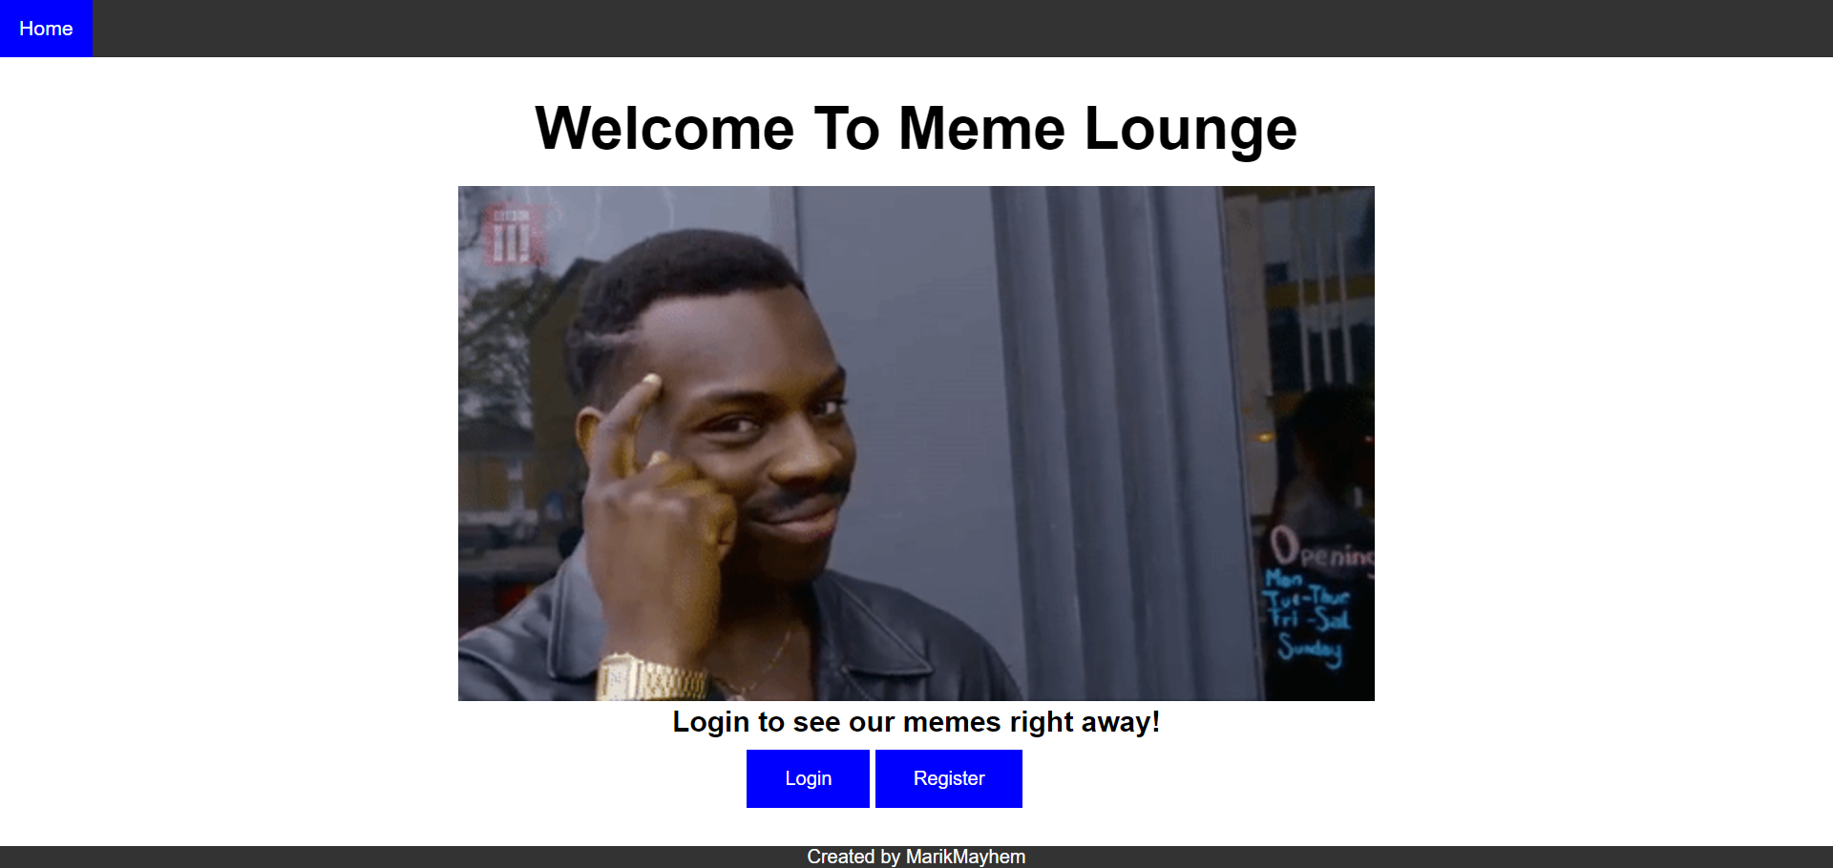

Register User (10 pts)
By given username, password and repeat password the app should register a new user in the system.
- After a successful registration, a notification message “User registration successful.” should be displayed and the catalog with all listings should be shown.
- You need to validate the input. A username should be at least 3 characters long and should contain only english alphabet letters. A user‘s password should be at least 6 characters long and should contain only english alphabet letters and digits. Both passwords must match.
- In case of error (eg. invalid username/password), an appropriate error message should be displayed and the user should be able to try to register again.
- Keep the user session data in the browser’s session storage.
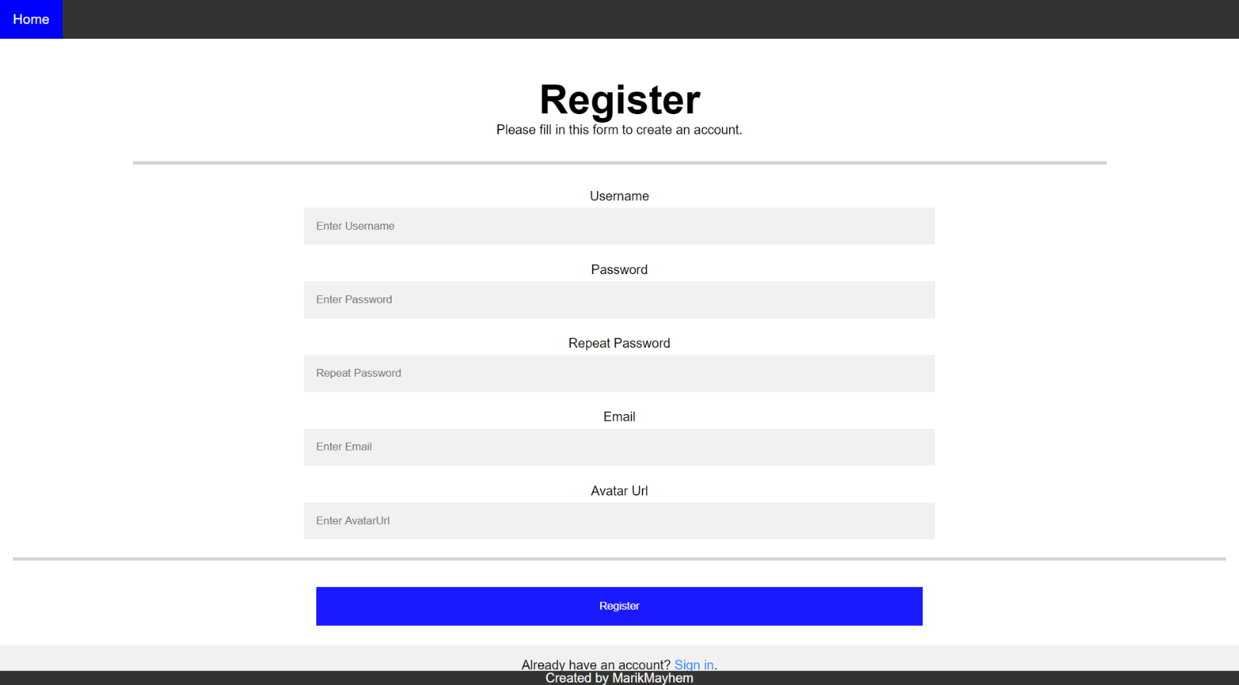

Login User (5 pts)
By given username and password the app should be able to login an existing user.
- After a successful login, a notification message “Login successful.” should be displayed and the user home screen should be displayed.
- In case of error, an appropriate error message should be displayed and the user should be able to fill the login form again.
- Form validation should be the same as register.
- Keep the user session data in the browser’s session storage.
- Clear all input fields after successful login.
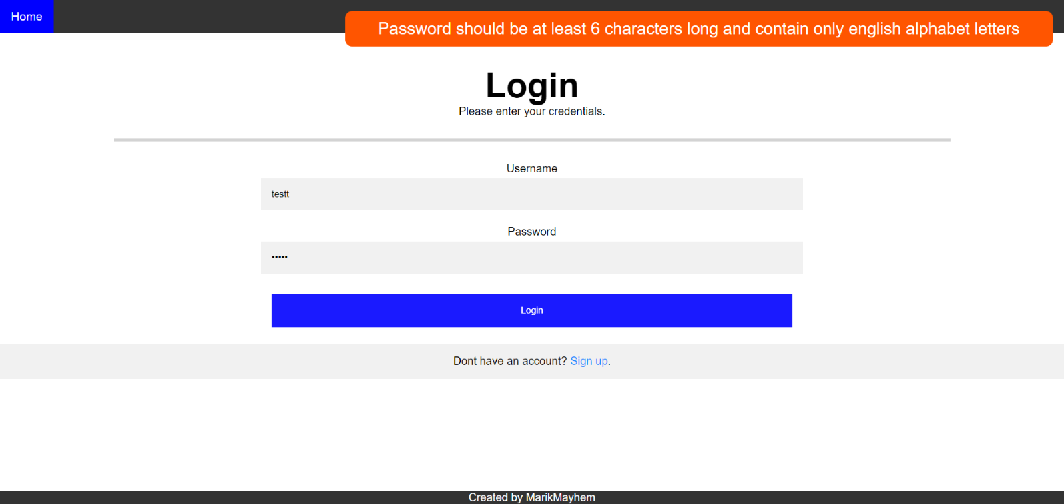

Logout (5 pts)
Successfully logged in user should be able to logout from the app.
- After a successful logout, a notification message “Logout successful.” should be displayed.
- After successful logout, the Sign In screen should be shown.
- The “logout” REST service at the back-end should be obligatory called at logout.
- All local information in the browser (user session data) about the current user should be deleted.

Meme Feed (15 pts)
Successfully logged users should be welcomed by the meme feed screen which can be accessed after clicking the Home link in the NavBar. The catalog contains all memes on the site.
- The memes should be listed in the format as shown in the Web design (see the screenshot below).
- Each meme has title and image;
- When the checkout(meme title and meme image)/edit link is clicked, your app should redirect to the details/edit section of the meme.
- When the creator button is clicked you should redirect to the creator profile.
- Meme creators can edit/delete their own memes.
- In case of error (e.g. Internet connection lost), an error message should be displayed.
- In case of no memes, display ‘No memes in database’.

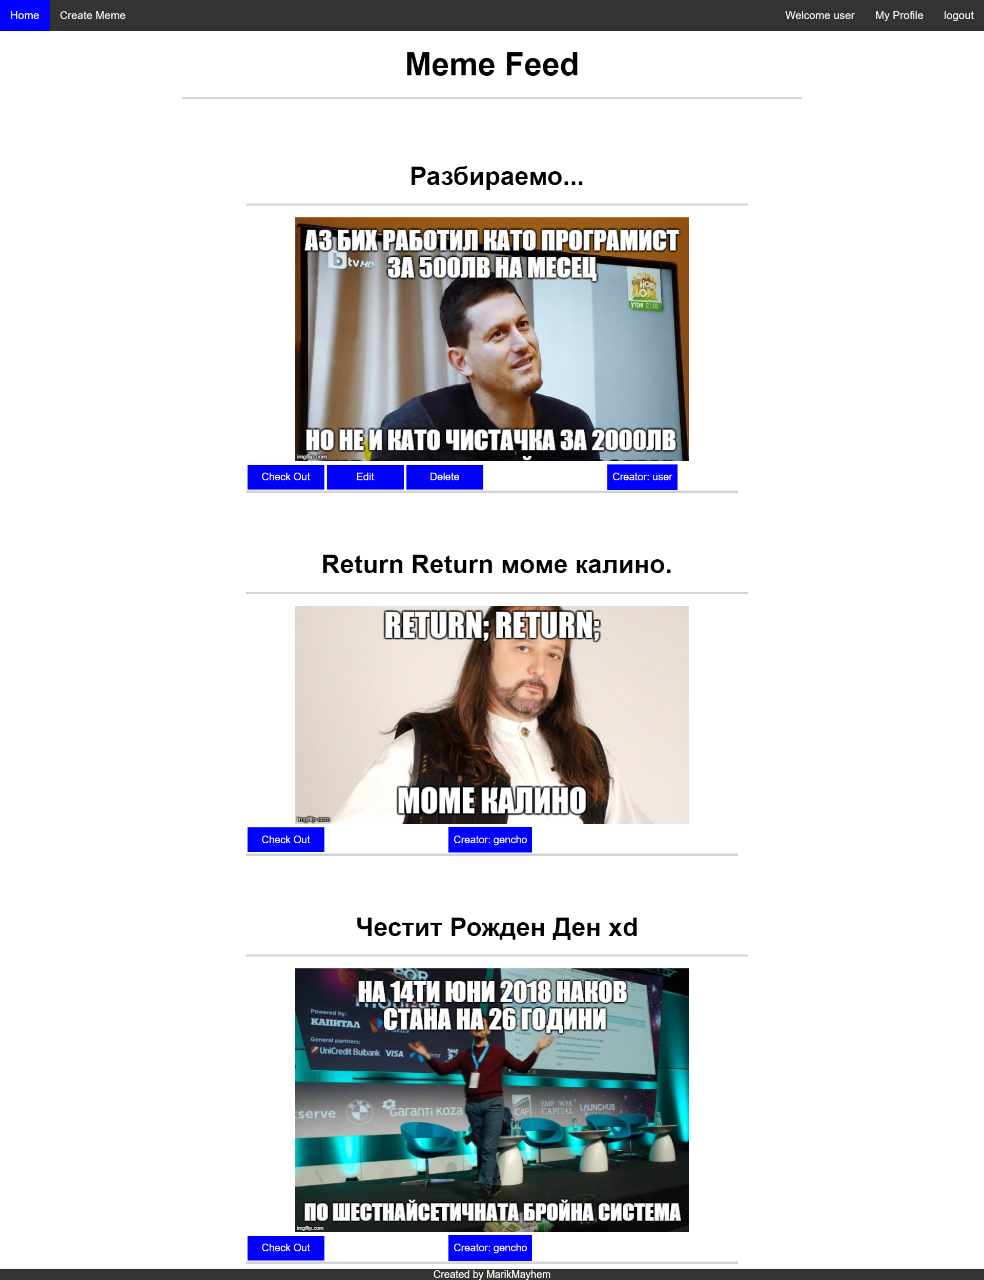

Create Meme Screen (10 pts)
Logged in users can create meme. Clicking the [Create Meme] link should open a form.
- After a successful meme creation, a notification message “meme created.” should be displayed and the meme feed should be shown.
- The title length must not exceed 33 characters!
- The description length must not exceed 450 characters and should be at least 30!
- Link url should always start with “http”.
- In case of empty/incorrect input fields an appropriate error message should be displayed and the user should be able to fill the form again.
- Ensure you handle properly all HTML special characters, e.g. the description text could hold "Hi, <peter>".
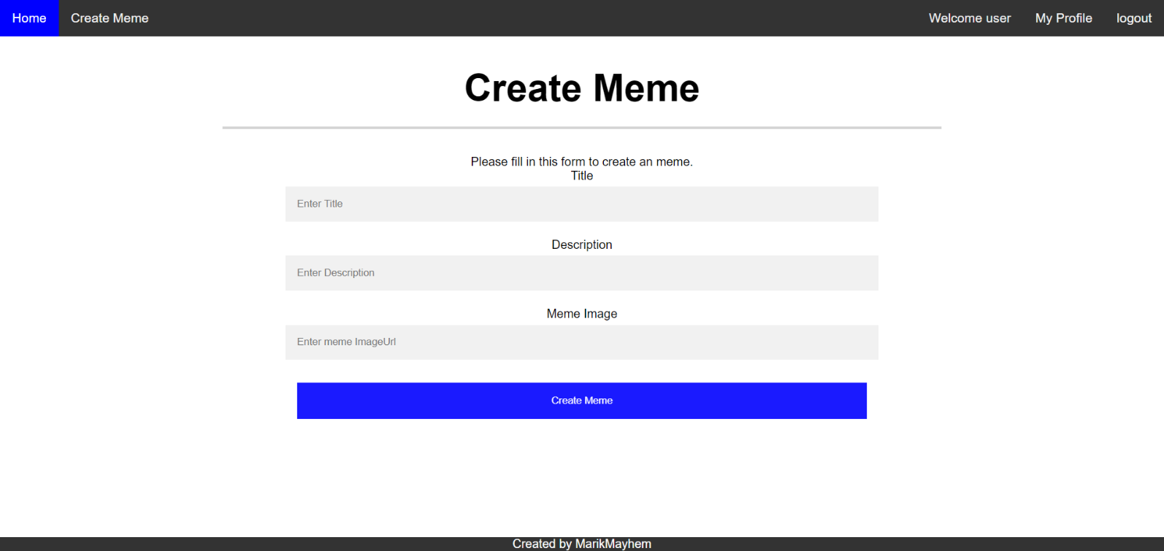

Edit Meme Screen (15 pts)
Sellers should be able to edit their own listings. Clicking the [Edit] link on each meme should open an edit form. Inside the edit form all input fields should be filled with the current data of each post.
- After a successful meme update, a notification message “Meme {memeTitle} updated.” should be displayed and the meme Feed should be shown.
- The validation is same as create meme!
- Ensure you handle properly all HTML special characters, e.g. the description text could hold "Hi, <peter>".

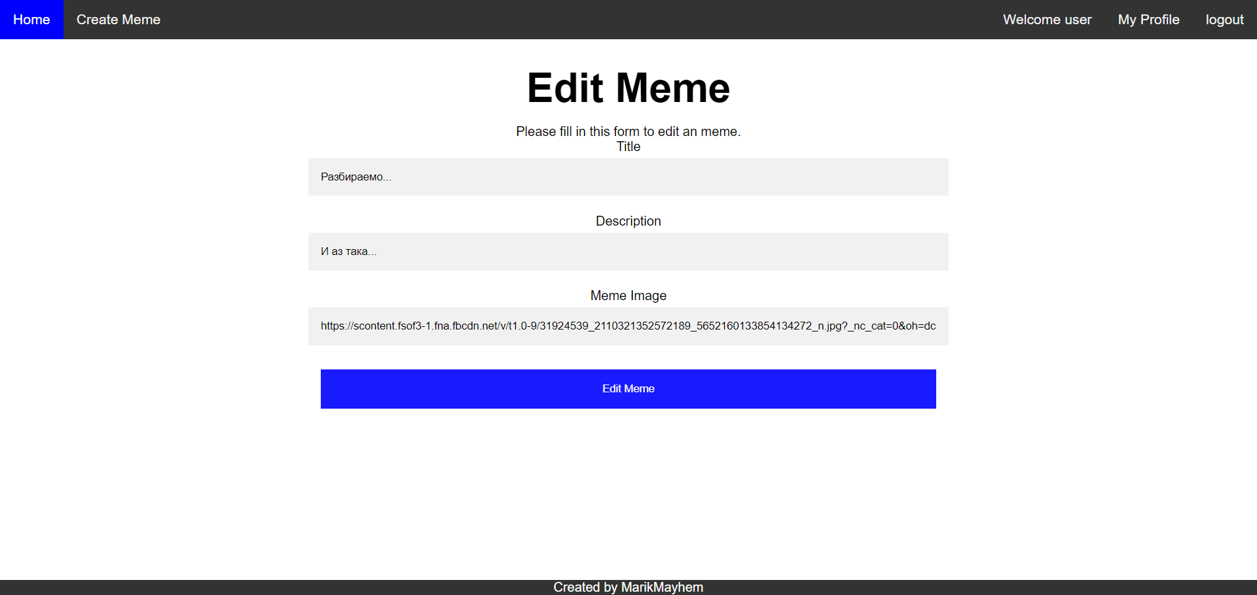

Delete Meme (5 pts)
Sellers should be able to delete their own memes by clicking the [Delete] button.
- After successful meme delete a notification message “Meme deleted.” should be displayed and the meme feed should be shown.
- In case of error (e.g. Internet connection lost / unauthorized request / missing message), an error message should be displayed.
- Deleting works immediately, with no confirmation.

User Profile (15 pts)
Each user should be able to view his own profile by clicking [My Profile]. The user can also see other people profiles by clicking the links on their memes.

- Each user profile should display user info - avatarImage,username and email.
- The memes should be listed like in the meme Feed section below the user Info.
- If the profile is of the current logged in user you should also have Delete user button.
- The user delete button should destroy the current user profile.
- After successful user delete a notification message “User deleted.” should be displayed and the meme feed should be shown.
- In case of error (e.g. Internet connection lost), an error message should be displayed.
- In case of no memes, display ‘No memes in database’.
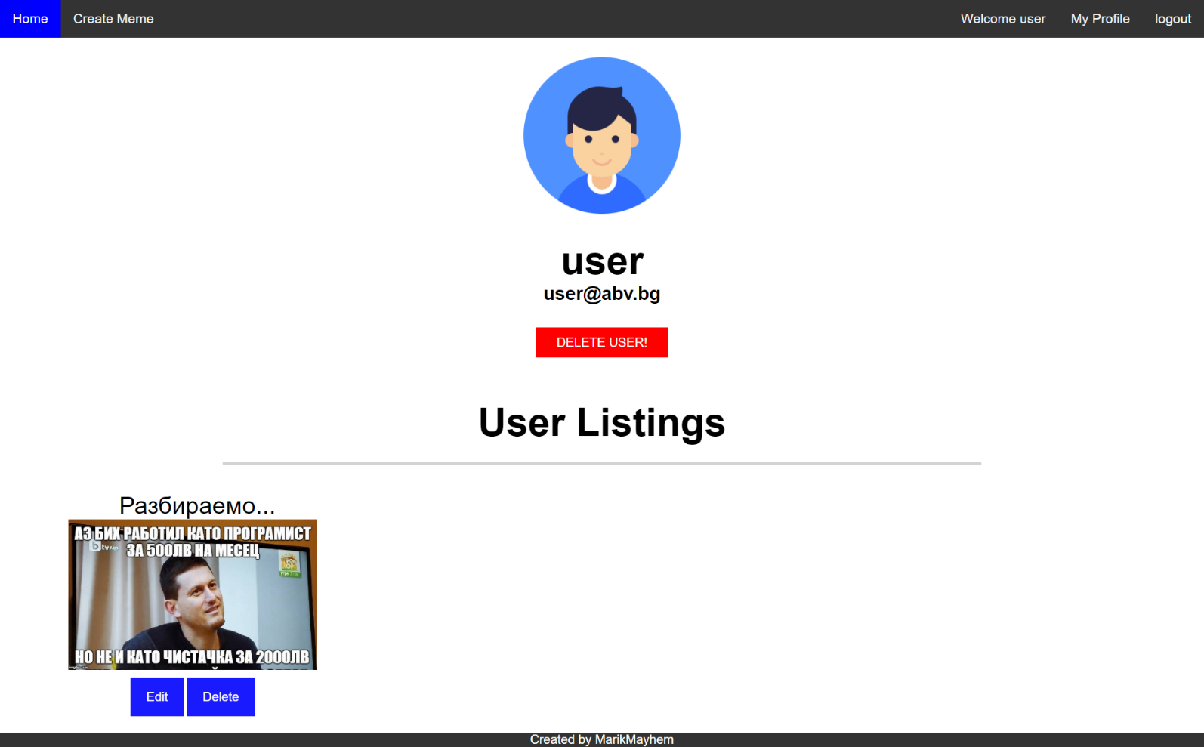

Meme Details (10 pts)
Each meme has a details view. By clicking the [details] link partial information about each meme should be listed!
- In case of error (e.g. Internet connection lost), an error message should be displayed.
- Ensure you handle properly all HTML special characters, e.g. the description text could hold "Hi, <peter>".
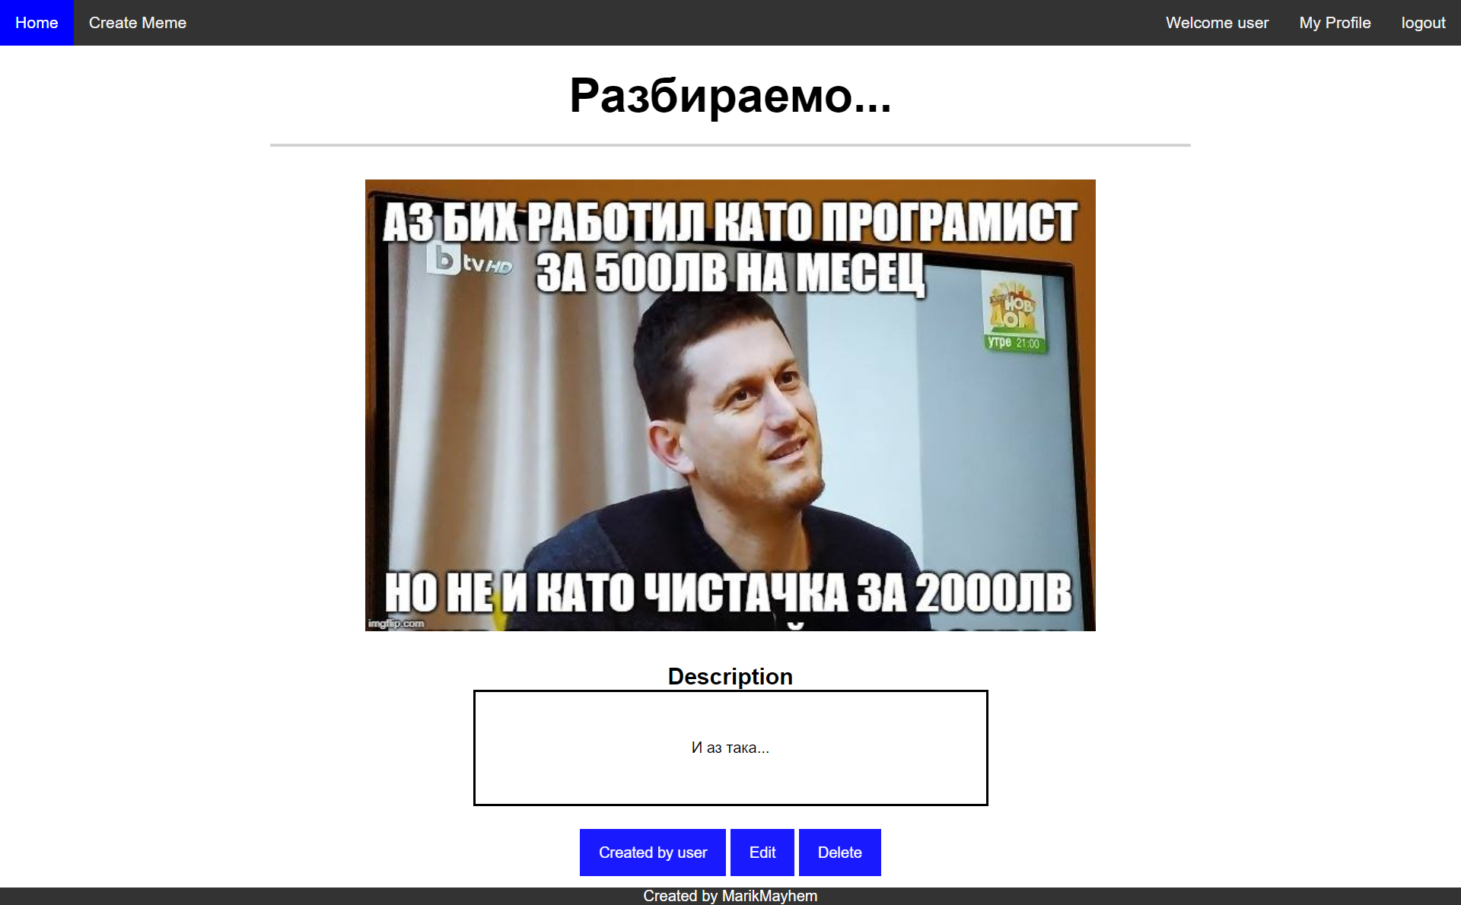

Subtmitting Your Solution
Place in a ZIP file your project folder. Exclude the node_modules folder. Upload the archive to the Judge.

